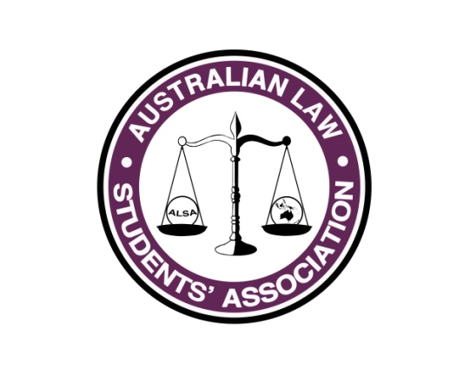
Marketing Report
Name: Grace Norris
Position: Marketing Officer
E-mail: marketing@alsa.asn.au

What has happened so far...
So far, the Facebook page likes have been skyrocketing. As of the 27/06, there have been more than 1,000 new likes on the Facebook page. Views are averaging at around 3,000 per post. We get generally 5-10 new followers on the Twitter per week.
The first and second ALSA newsletters have also gone out. The four newsletter per year system is working really well in my experience, and we have the perfect amount of material for each newsletter.
The share for share system is slowly starting but there is more to be done between July and October.

What you plan to do between now and July Conference
Marketing for the elections are in full swing. The agent profile, although riddled with spelling mistakes, are reaching high numbers with about 3000 each (so far). Focus is being put on the fact that you do not need to be at Council to apply. International Careers Guide is also out and the posts are reaching good numbers, and I intend to continue posting every few days up until Conference.

