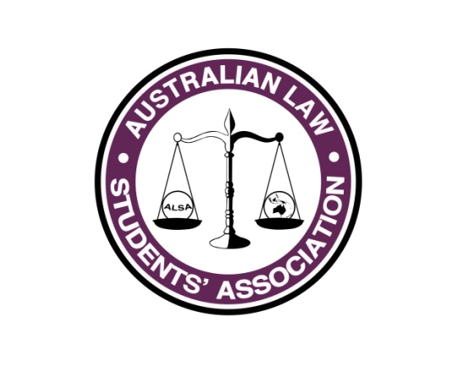
Sponsorship Report
Name: Andy (Andreena) Kardamis
Position: Director of Sponsorship
E-mail: sponsorship@alsa.asn.au

What has happened so far...
I have been working on sponsorship since September 2015. I have re-designed the Sponsorship Prospectus with InDesign in order to make it a professionally viewed document and introduced a sponsorship system to entice organisations to sponsor multiple events. I sent the Prospectus to firms in the first week of December, and have been engaged in the sponsorship process since that timeframe.
Paul and myself attended sponsorship meetings in Sydney with approximately 9 firms to discuss sponsorship opportunities available.
I have predicted the minimum sponsorship to be $65,000 and the maximum to be $80,000 to $90,000. Last year sponsorship totalled $42,000.

What you plan to do between now and July Conference
I am engaging non-law firm sponsors and will continue to do this until July Conference. I am also coordinating the Communications Strategy and am the NSW Representative.
I have a team of 8 from the ALSA Committee who are in my sub-committee for the Communications Strategy. I have written a strategy, and as a team we will be meeting the tasks of the strategy to ensure that all of ALSA stakeholders are aware of what is happening with ALSA, and any updates.
NSW Representative’s objective is to ensure that all NSW President’s have a point of contact for ALSA, Simon McNamara chair of the SCLSS Committee of NSWYL (Immediate Past President of UNSW) will be assisting with this. This means that I will be attend the meetings of NSWYL Special Committee of Law Student Societies (SCLSS), in order to maintain face to face contact with President’s of NSW.

