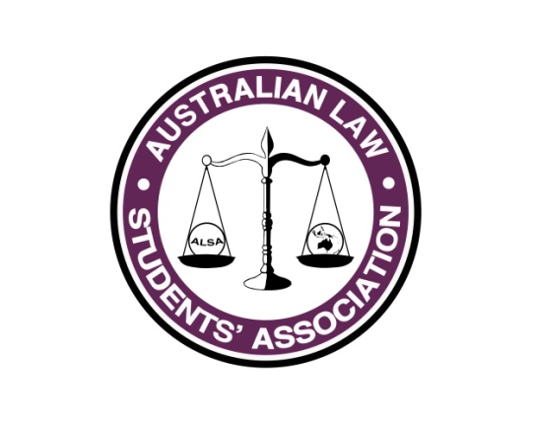
President’s Report
Name: Paul Melican
Position: President (ALSA)
E-mail: president@alsa.net.au

What has happened so far...?
Welcome to Council @ Conference! As per last time my report is a summary of the major items we have completed please look into the portfolio reports for further details.

The biggest issue that we have had since February Council has been our e-mail outage, which took a long time for us to rectify, about five weeks all up. ALSA has a very fragile e-mail structure and Stef Fraser (Risk Officer) and Lachlan Foster (IT Officer) are looking to address this so it does not occur again.

Advocacy
- Letter to State A-G’s et al on Mental Health disclosures at the time of admission has been sent, we have had little feedback on this.
- Letter to Federal Minister for Education on Fee-HELP issues but due to the election we have been somewhat curtailed on progressing discussions on this.
- Petition on the cost of Uni Books is up, awaiting signatures.

Education
- International Careers Guide, which you will receive a copy of.
- Knowledge sharing sessions have been run on

Competitions
- National Essay Competition has been run, winner to be announced soon
- Review of the ALSA Competition rules and new rules are being used our 2016 competitions

Committee & Internal ALSA
- Filled our ASO position, Elise Steegstra from RMIT LSS.
- We have closed the old Incorporated Association which is the final step in our now two year transition to a combined company limited by guarantee, although I do have to close the old bank accounts.
- New By-laws, cleaning up the old ones which were contradictory in places and contradicted the constitution. We have not made any substantive changes just bring them together and bringing in the relevant sections of the constitution.

I am sure there is much more which will come out over our week of council and in the committee reports.

Constitutional Amendments
We have three;
- To remove the requirement for ALEF’s at Conference in order to allow Canberra 2017 to be shorter by a day.
- Clear up the company’s objective to ensure we are following a charitable purpose – we need this to get tax exempt status.
- Clear up the company’s objective to ensure we are following a charitable purpose – we need this to get tax exempt status. Same as number two.

What you plan to do between now and the end of your term?
We have a few things left before we all become lame ducks, but the focus of the President’s term between July and September is mainly on handover and setting up the plan for the new executive (I can’t believe my term has gone so quickly! ).

New South Wales Young Law Public Interest Careers Fair Wednesday 3 August, which we will be doubling up with a dedicated webpage on the ALSA site with details for people in other states.

ALSA Academic Journal will come out towards the Aug-16, it will be a combined 2015-16 edition. It is recommended that it be issued every second year going forward due to the number of submissions required to get a good journal out.

Based on the direction from Council we will continue to progress our advocacy platform.

Knowledge Sharing Sessions on Equity Programs; Sponsorships; Careers Guides; Social Media Strategies and we welcome more topics.

R U OK Day 10-October.

Further Andrew Lonergan (Conference Convenor 2016) and I will be working on developing a ‘How to run a Council Guide’ as presently there is very little information about it.

